**People Counter**

This project aims to create a software which uses computer vision to count the number of people on the street. One would need to install a camera and see what the local laws are before starting however I will be using an already established online video stream as our video source.

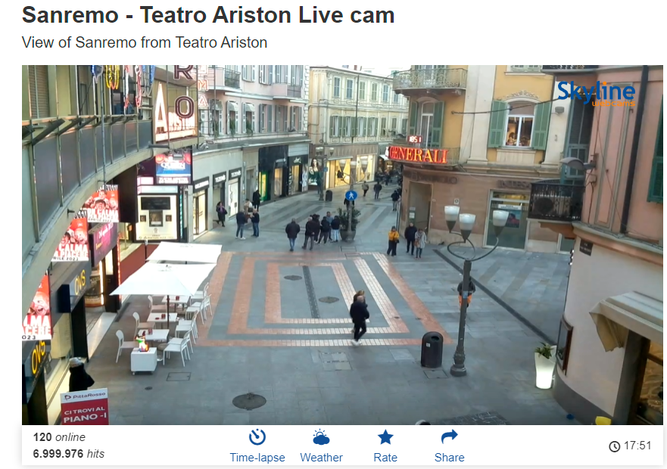

After capturing the video from a source the software will be using ImageAI library by [OlafenwaMoses](https://github.com/OlafenwaMoses/ImageAI/commits?author=OlafenwaMoses) with the ResNet50 Model. The Image AI will be given individual images from the video and it will output a list of items it identified, the software will pick out only images identified as people.

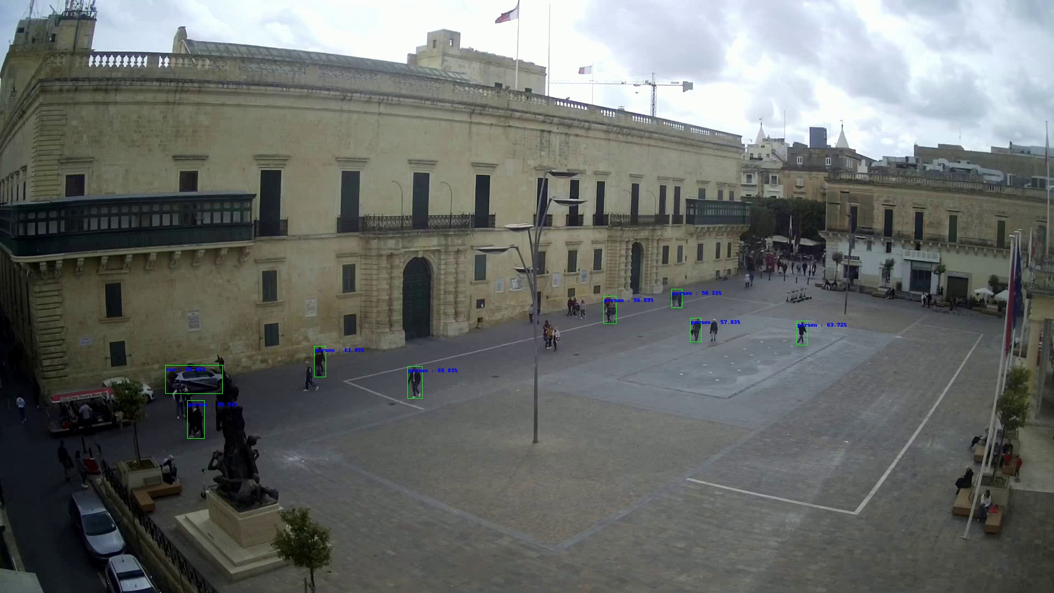

With the list of people identified with each picture as to have an accurate count the biggest number between 10 pictures will be selected. The ImageAI library has a lot of false negatives but as far as I have seen it never had any false positives while testing, I am more worried of under-representing the amount of people in the street rather than over-representing.

The data will be put into a .csv file with two headers, people and date. After enough data is collected I can have an estimate of how many people I can predict to have during a set time within reason. The estimation can vary due to external conditions like seasons, holidays or weather, if one wants to predict these variables a bigger dataset needs to be taken in account.

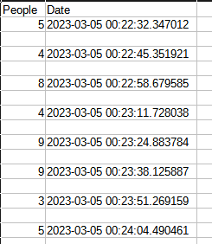

With the data I collected a bar chart can be plotted of the total visits per day, average visits per hour and hour visit amount

